UCS 1511 - Network Lab
Chat using TCP

Name: Kshitij Sharma Reg No: 185001080 Date: 08-09-2020

Aim:

To write a socket program to perform chat with multiple clients using TCP.

Algorithm:

- Server

  - Create a socket descriptor with socket() system call with AF INET (IPV4 domain), SOCK STREAM, default protocol and store as sockfd.

  - If sockfd is a negative number, socket creation failed, end program.

  - Create sockaddr in object to assign IP address and Port number for socket. Set family to AF INET, IP address to INADDR ANY to accept connections from any client and port number required.

  - Bind newly created socket to addresss given in sockaddr in.

  - If bind is non zero, bind failed, print error message and terminate.

  - Listen on the socked de ned for as many clients as required. If listen() returns non zero value, print error message and terminate.

  - LOOP:

    - Clear readfds using FD ZERO()

    - Add server socket descriptor to FD SET readfds.

    - check for activity on socket using select() system call.

    - IF activity < 0, print error message and terminate

    - Check if sockfd (socket descriptor) is readfds set using FD ISSET(); IF true,

New connection detected, accept() new client and get client descriptor Store new client descriptor in array of client descriptors

Remove server socket descriptor from readfds.

    - Loop through all client descriptors and add them to the FD SET readfds.

    - Check for activity using select() command. IF detected

Loop through clients one by one and check if they are in the set using FD ISSET(). Read message into bu er using read() command

IF message read is ‘END’, remove this client from client array

ELSE, display the message and send response to the client using write().

  - Close connections on socket using close() and terminate program.

- Client

  - Create a socket descriptor with socket() system call with AF INET (IPV4 domain), SOCK STREAM, default protocol and store as sockfd.

  - If sockfd is a negative number, socket creation failed, end program.

  - Create sockaddr in object to assign IP address and Port number for socket. Set family to AF INET, IP address to localhost(127.0.0.1) to connect to server and port number required.

  - Connect the client to server at address given in socket descriptor using connect() system call.

  - If connect() returns -1, connection failed; Print error message and terminate the program.

  - Read message from user into bu er variable.

  - IF the message is END, terminate the program and close the socket descriptor using close() system call.

  - ELSE, write message into server socket using write() system call.

  - Read the response from server into bu er variable using read() system call and display received message to the user.

  - Repeat from step 6.

Program

1. Server Side

#include<stdio.h>
#include<unistd.h>
#include<fcntl.h>
#include<arpa/inet.h>
#include<sys/types.h>
#include<sys/socket.h>
#include<netinet/in.h>
#include<stdlib.h>
#include<string.h>
#define PORT 8080
#define MAX 1024
#define SA struct sockaddr

int main(int argc, char **argv)
{
int len, clients[5], selsd;
int sockfd, newfd, n = 0;
struct sockaddr_in servaddr, cliaddr;

fd_set readfds;

char buff[1024];
char str[1000];

for(int i = 0; i < 5; i++)
clients[i] = 0;

sockfd = socket(AF_INET, SOCK_STREAM, 0);
printf("Server Socket is created.\n");

if(sockfd < 0)
perror("Cannot create socket!\n");

bzero(&servaddr, sizeof(servaddr));
servaddr.sin_family = AF_INET;
servaddr.sin_addr.s_addr = htonl(INADDR_ANY);
servaddr.sin_port = htons(PORT);

if((bind(sockfd,(SA*)&servaddr,sizeof(servaddr)))!=0)
{
printf("Socket bind failed..\n");
exit(0);
}
printf("Socket successfully binded..\n");

if(listen(sockfd, 5) == 0){
printf("Listening....\n");
}else{
printf("Error in binding.\n");
}
len = sizeof(cliaddr);
int all_clients_open =1;
while(all_clients_open==1) {
FD_ZERO(&readfds);
FD_SET(sockfd, &readfds);

selsd = sockfd;
for(int i = 0; i < 5; i++) {
int sd = clients[i];
if(sd > 0) FD_SET(sd, &readfds);
if(sd > selsd) selsd = sd;
}

int activity = select(selsd + 1, &readfds, NULL, NULL, NULL);

if(FD_ISSET(sockfd, &readfds)) {
newfd = accept(sockfd, (struct sockaddr*)&cliaddr, &len);
for(int i = 0; i < 5; i++) {
if(clients[i] == 0) {
clients[i] = newfd;
break;
}
}
}

for(int i = 0; i < 5; i++) {
if(FD_ISSET(clients[i], &readfds))
{
read(clients[i], buff, 1024);
if(strncmp(buff,"exit",4)==0)
{
close(clients[i]);
clients[i] = 0;
printf("[-]Client %d closed!\n", i+1);
all_clients_open=0;
for(int k=0;k<5;k++)
{
if(clients[k]!=0)
{all_clients_open=1;break;}
}
}
else {
printf("Client %d: %s", i+1, buff);
bzero(buff,MAX);
printf("To Client %d: ",i+1);
n=0;

while((buff[n++]=getchar())!='\n');
write(clients[i],buff,sizeof(buff));
}
}
}
}
printf("All clients are closed.. Server shutting down..\n");
close(sockfd);
return 0;
}

2. Client Side

#include<stdio.h>
#include<unistd.h>
#include<sys/types.h>
#include<sys/socket.h>
#include<arpa/inet.h>
#include<netinet/in.h>
#include<string.h>
#define PORT 8080
#define MAX 1024
#define SA struct sockaddr

int main(int argc, char **argv)
{
int len;
int sockfd, n = 0;
struct sockaddr_in servaddr, cliaddr;
char str[1000];
char buff[1024];
sockfd = socket(AF_INET, SOCK_STREAM, 0);
if(sockfd == -1)
{
printf("socket creation falied..\n");
exit(0);
}
else
{
printf("Socket successfully created.\n");
}

bzero(&servaddr, sizeof(servaddr));
servaddr.sin_family = AF_INET;
servaddr.sin_addr.s_addr = inet_addr("127.0.0.1");
servaddr.sin_port = htons(PORT);

if(connect(sockfd,(SA*)&servaddr,sizeof(servaddr))!=0)
{
printf("Connection with the server failed..\n");
exit(0);
}

else
{
printf("Connected to the server..\n");
}

while(1) {
bzero(buff,MAX);
printf("Enter Message to Server: ");
int s=0;

while((buff[s++]=getchar())!='\n');
n = write(sockfd, buff, sizeof(buff));
if(strncmp(buff,"exit",4)==0)
break;
bzero(buff,MAX);
read(sockfd,buff,sizeof(buff));
printf("Message from server: %s",buff);
}
close(sockfd);
return 0;
}

OUTPUT:

SERVER

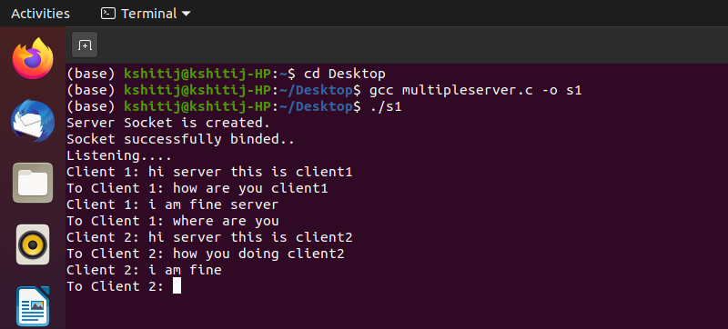

CLIENT1

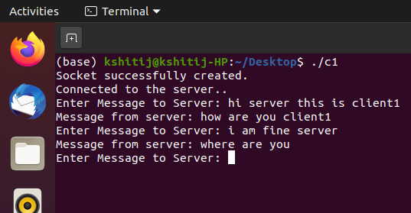

CLIENT 2

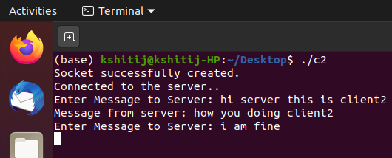

Learning Outcomes:

- We learn how to create a simple TCP client server connection.
- We learn how a server can communicate with multiple clients without using fork commands.
- We learn how to appropriate system calls to set up a Server and Client .
- We learn to use select() to detect activity on descriptors.
- We learn to handle multiple clients using a single program thread.

